R Abhinav

205001001

CSE-A

**Ex. No. 5 Android Application using Multithreading**

**Aim:**

Develop an android application to perform multithreading. Define 3 threads to run concurrently when “start” button is clicked.

The first thread should change the color of the text indefinitely The second thread should implement a moving banner

The third thread should display a counter starting from 0 to 1000 When the “Stop” button is pressed all the threads should be stopped

**Layouts Used:** None. Three textViews.

**Code:**

**MainActivity.java:**

package com.example.ex5;

import androidx.appcompat.app.AppCompatActivity;

import android.graphics.Color;

import android.os.Bundle;

import android.util.Log;

import android.view.View;

import

android.widget.Button;

import android.widget.TextView;

public class MainActivity extends AppCompatActivity {

@Override

protected void onCreate(Bundle savedInstanceState) { super.onCreate(savedInstanceState);

setContentView(R.layout.activity_main);

TextView t1 = findViewById(R.id.t1);

Thread1 th1 = new Thread1(t1);

TextView t2 = findViewById(R.id.t2);

Thread2 th2 = new Thread2(t2);

TextView t3 = findViewById(R.id.t3);

Thread3 th3 = new Thread3(t3);

final boolean[] init = {false};

Button start = findViewById(R.id.start);

start.setOnClickListener(new View.OnClickListener() { @Override

public void onClick(View v) {

if(!init[0]){

th1.start();

th2.start();

th3.start();

init[0] = true;

}

else{

Log.d("debug","hello");

th1.pause(false);

th2.pause(false);

th3.pause(false);

}

}

});

Button stop = findViewById(R.id.stop);

stop.setOnClickListener(new View.OnClickListener() { @Override

public void onClick(View v) {

th1.pause(true);

th2.pause(true);

th3.pause(true);

}

});

}

}

**Thread1.java:**

package com.example.ex5;

import android.graphics.Color;

import android.util.Log;

import android.widget.TextView;

public class Thread1 extends Thread{ TextView t;

int red = 120;

int green = 120;

int blue = 120;

boolean paused = false;

Object lock = new Object();

Thread1(TextView t){

this.t=t;

}

public void pause(boolean paused){ synchronized (lock){

if(paused)

this.paused = true;

else{

this.paused = false;

lock.notifyAll();

}

}

Log.d("Debug",""+paused);

}

public void run(){

while(true) {

try {

int color = Color.rgb(red, green, blue); t.setTextColor(color);

red = (red + 20) % 255;

green = (green + 10) % 255;

blue = (blue + 5) % 255;

Thread.sleep(500);

synchronized (lock){

while(paused){

try{

lock.wait();

}catch(InterruptedException e){

}

}

}

} catch (InterruptedException e) {

e.printStackTrace();

}

}

}

}

**Thread2.java:**

package com.example.ex5;

import android.util.Log;

import android.view.animation.TranslateAnimation; import android.widget.TextView;

public class Thread2 extends Thread{

TextView t;

int dir = 1;

int translationDistance = 300; boolean paused=false;

Object lock = new Object(); Thread2(TextView t){

this.t=t;

}

public void pause(boolean paused){ synchronized (lock){

if(paused)

this.paused =

true;

else{

this.paused = false;

lock.notifyAll();

}

}

Log.d("Debug",""+paused); }

public void run(){

while (!paused) {

try {

TranslateAnimation animation;

if (dir == 1) {

animation = new TranslateAnimation(-translationDistance, translationDistance, 0, 0);

} else {

animation = new TranslateAnimation(translationDistance, -translationDistance, 0, 0);

}

animation.setDuration(3000); // Keep the total duration the same animation.setFillAfter(true);

t.startAnimation(animation);

Thread.sleep(3000)

; dir = 1 - dir;

synchronized (lock){

while(paused){

try{

lock.wait();

}catch(InterruptedException e){

}

}

}

} catch (InterruptedException e) {

e.printStackTrace();

}

}

}

}

**Thread3.java:**

package com.example.ex5;

import android.util.Log;

import android.widget.TextView;

public class Thread3 extends Thread{ TextView t;

int ctr=0;

boolean paused = false;

Object lock = new Object();

Thread3(TextView t){

this.t=t;

}

public void pause(boolean paused){ synchronized (lock){

if(paused)

this.paused =

true;

else{

this.paused = false;

lock.notifyAll();

}

}

Log.d("Debug",""+paused);

}

public void run(){

while (ctr < 3000 && !paused) {

try {

Thread.sleep(1000)

; ctr += 1;

// Update the TextView on the UI thread t.post(new Runnable() {

@Override public

void run() {

t.setText(Integer.toString(ctr));

}

});

synchronized (lock){

while(paused){

try{

lock.wait();

}catch(InterruptedException e){

}

}

}

} catch (InterruptedException e) {

paused = true;

e.printStackTrace();

}

}

}

}

**Activity_main.xml:**

<?xml version="1.0" encoding="utf-8"?>

<androidx.constraintlayout.widget.ConstraintLayout xmlns:android="http://schemas.android.com/apk/res/android"

xmlns:app="http://schemas.android.com/apk/res-auto" xmlns:tools="http://schemas.android.com/tools" android:layout_width="match_parent"

android:layout_height="match_parent"

tools:context=".MainActivity"

tools:layout_editor_absoluteX="-1dp"

tools:layout_editor_absoluteY="-83dp">

<TextView

android:id="@+id/t1"

android:layout_width="wrap_content"

android:layout_height="wrap_content"

android:text="Hello World!"

android:textSize="24sp"

app:layout_constraintBottom_toBottomOf="parent" app:layout_constraintHorizontal_bias="0.498" app:layout_constraintLeft_toLeftOf="parent" app:layout_constraintRight_toRightOf="parent" app:layout_constraintTop_toTopOf="parent" app:layout_constraintVertical_bias="0.383" />

<TextView

android:id="@+id/t2"

android:layout_width="wrap_content"

android:layout_height="wrap_content"

android:text="Hello World!"

android:textSize="24sp"

app:layout_constraintBottom_toBottomOf="parent" app:layout_constraintHorizontal_bias="0.501" app:layout_constraintLeft_toLeftOf="parent"

app:layout_constraintRight_toRightOf="parent" app:layout_constraintTop_toTopOf="parent" app:layout_constraintVertical_bias="0.266" />

<TextView

android:id="@+id/t3"

android:layout_width="wrap_content"

android:layout_height="wrap_content"

android:text="0"

android:textSize="24sp"

app:layout_constraintBottom_toBottomOf="parent" app:layout_constraintHorizontal_bias="0.498" app:layout_constraintLeft_toLeftOf="parent" app:layout_constraintRight_toRightOf="parent" app:layout_constraintTop_toTopOf="parent" app:layout_constraintVertical_bias="0.155" />

<Button

android:id="@+id/stop"

android:layout_width="wrap_content"

android:layout_height="wrap_content"

android:layout_marginTop="76dp"

android:text="Stop"

app:layout_constraintEnd_toEndOf="parent" app:layout_constraintHorizontal_bias="0.684" app:layout_constraintStart_toStartOf="parent" app:layout_constraintTop_toBottomOf="@+id/t1" />

<Button

android:id="@+id/start"

android:layout_width="wrap_content"

android:layout_height="wrap_content"

android:layout_marginTop="76dp"

android:text="Start"

app:layout_constraintEnd_toEndOf="parent" app:layout_constraintHorizontal_bias="0.236" app:layout_constraintStart_toStartOf="parent" app:layout_constraintTop_toBottomOf="@+id/t1" />

</androidx.constraintlayout.widget.ConstraintLayout> **Output:**

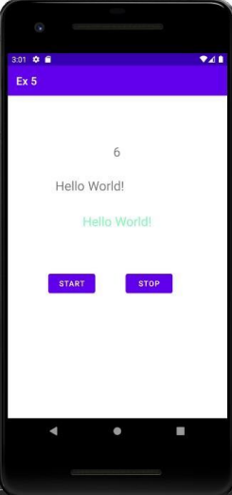

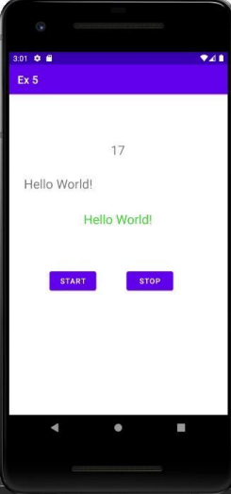

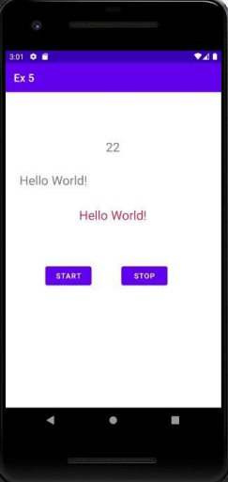

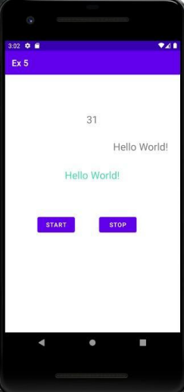

**Best Practices:**

● Names for ids of buttons were set meaningfully ● Implemented pause and resume in a single function

● Handled exceptions

**Learning Outcomes:**

● Learnt to implement multithreading ● Learnt to start, stop and resume threads